Welcome Back

TPFSC News

Canskate

Work Hard | Have Fun Ca
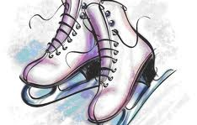
Hello everyone. We hope you all had a great summer break. We are so excited to be back in the rink for another skating season. There are lots of fun things planned for this year and we look forward to another exciting year. Always remember to work hard and have fun. Please remember that it takes a lot of hard work, time and dedication to run this club and everyones views, ideas and suggestions are equally as important. If you have an observation or suggestion please feel free to direct these to a member of the executive or a coach in a respectful manner and know that it will be addressed to the best of our ability. Let’s have a great year everyone!

CanSkate Schedule
PreCanSkate, and stages 1&2 - Friday, 6:30 - 7:15
3,4,5,6 CanSkate - Friday, 7:15 - 8:00

Important Dates
Additional Registration - Oct. 3
First CanSkate Session -
Oct. 10
CanSkate Theme Days:
Oct. 17 - Beach Day
Oct. 24 - PJ Day
Oct. 31 - Halloween
Skaters are asked to dress in ways that reflect the theme of the night. Please keep in mind that clothing should not be loose and accessories should not be worn so that we are creating an environment that is fun but SAFE

Websites
Facebook Pages:
TPFSC CanSkate
Information Group
TPFSC home page:
tpfsc.weebly.com

2014 - 2015 Executive Members
President Bobbi-Lynn Deering blhollett@hotmail.com
Vice President Tammy Warren tammywarren80@yahoo.ca
Secretary Stephanie Phillips sissysfree@hotmail.com
Treasurer Kim Newhook kimanewhook@hotmail.com
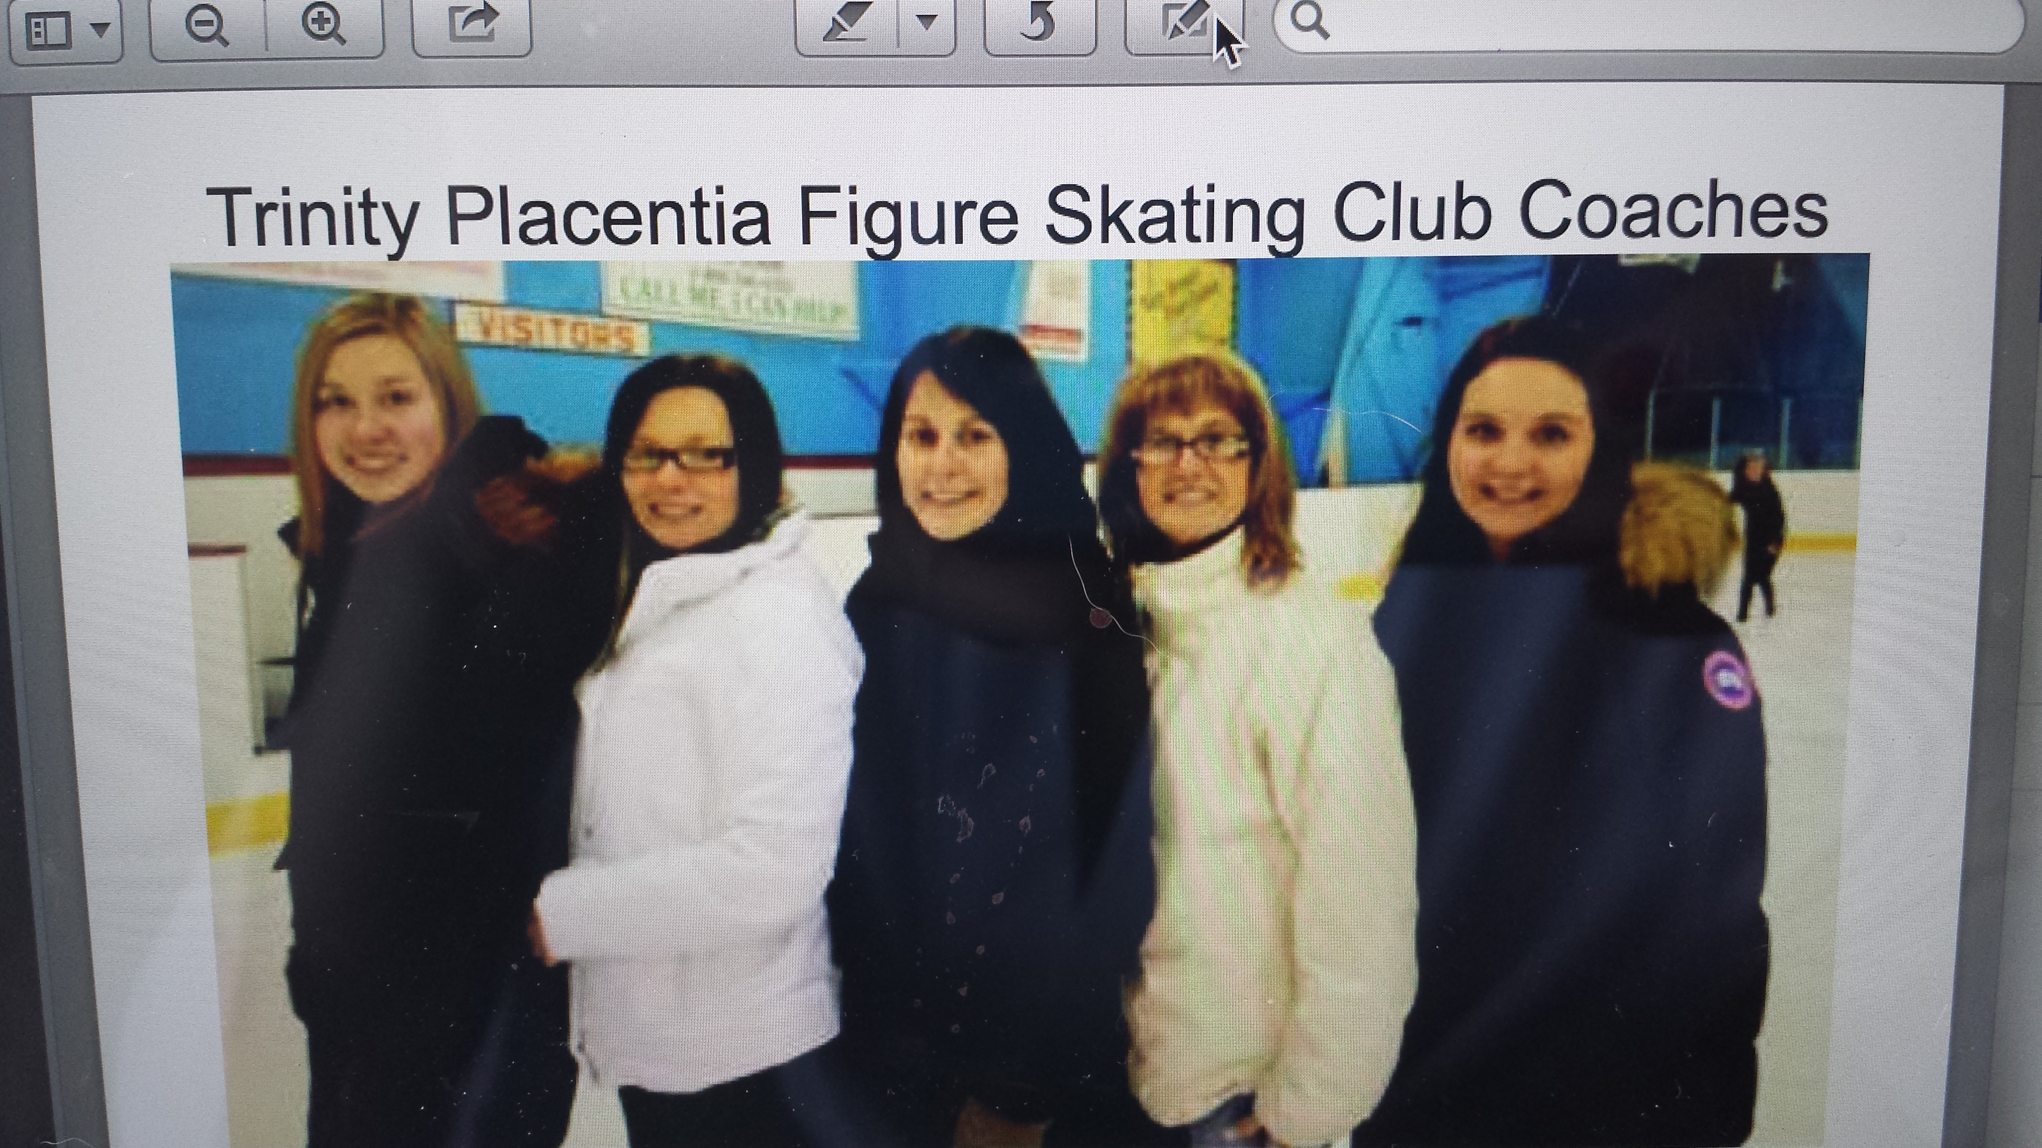
CanSkate Co-Ordinator Courtney Murphy courtneygen@hotmail.com

CanSkate Coaches
Jennifer Reid
jenn_hutchings@hotmail.com
Cassidy Newhook
cassidynewhook@hotmail.com
Sarah George sarahgeorge96@hotmail.com

Beginner Synchro Dana Smith danasmith@personainternet.ca
What is CanSkate?
“Skaters of all ages learn best when they are active, engaged, moving, challenged, motivated and having fun. That is what CanSkate is all about!
As Skate Canada’s flagship learn-to-skate program that is geared to beginners of all ages, CanSkate offered basic skating instruction taught in a group lesson format but Skate Canada professional coaches who are assisted by trained program assistants.
For CanSkaters, speed, flexibility and solid aspics are the most important aspects to be trained. This is accomplished by ensuring increased movement on the ice, using strategies such as circuits, the fast track, effective warm ups and cool downs, and having better skill progressions where the skills reoccur on several stages to develop the skills to a higher level of proficiency at each level.”
- Skate Canada CanSkate Manual
CanSkate Program Objectives
- To provide participants and families with a safe, welcoming and inclusive first experience in the sport of skating.
- To develop skating and motor skills though natural learning phases
- To use skill progression and repetition throughout the stages to introduce physical literacy and establish quality basic skating skills.
- To foster personal achievements and satisfaction through skill acquisition, rewards and recognition.
- To evoke an interest in life long participation in skating.
- Taken from Skate Canada CanSkate Manual
Session Layout
- Warm up (Whole Group)
- Lesson Time X 3 (colour Group)
- Group Activity (Colour Group)
- Cool Down (Whole Group)
*** Each section will come to an end on the Fast Track signal where skaters will skate around the perimeter of the ice before moving to their next session***

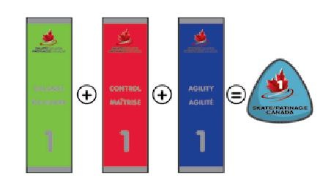
Assessment
Our coaches will be assessing skaters on a nightly basis. Skaters will receive 3 Fundamental Area Ribbons for each stage and 6 stage badges. A skater must receive all ribbons for the stage before receiving their badge. However, if a ribbon is received they can work on the skills in this fundamental area of the next stage. (ex. If the skater receives a stage 1 Balance ribbon, they have not moved onto stage 2 but can begin working on skills in the stage 2 balance area.)

Session Format
The CanSkate program skills have been divided into three basic Fundamental areas:
1.) Balance: Concentrating on most forward skills, pushing technique and edges.
2.) Control: Concentrating on most backwards skills, stopping and speed elements.
3.) Agility: Concentrating on most turning and jumping skills.

Control

Balance

Control

Balance

Agility

Agility

Pre CanSkate

Fun Zone
Pre CanSkate, Stage 1 & 2 Format
Pre CanSkate group will enter ice once general warm up is over and will remain in their section for their 30 minute session having their own warm up, circuit, games and cool down.

Stages 1 & 2 will rotate through the fundamental skills during their 45 minute session. Each week one of the skills sections will become the Fun Zone incorporating skills from that fundamental area.
Stages 3,4,5,6 Format
Skaters will rotate between each of the 4 areas during their 45 minute session.

Pre CanSkate
Pre CanSkate is designed to help skaters learn the basic skills needed to begin a CanSkate program. In the Pre CanSkate setting your child with receive more individualized attention from our trained program assistants (PA). The Pre CanSkate session will consist of a 10 minute warm-up, 10 minute lesson with a Skate Canada coach and 10 minutes of group activity/cool down. Theses skaters will not be expected to move from one section of the ice to the other as the goal is to maximize their on ice time for skill development.
We have decided to include the Pre CanSkate Session on with Stages 1 & 2 to help ease transition. This is also the case with our PAs. There will be one program assistant to every 2-3 skaters so that the transition into stage one will help your skater to develop more independence. Due to availability of PAs we ask that any skater under the age of 4 after Dec. 31 be accompanied by a Skate Canada Registered adult.

